Project Design Phase-II

Technology Stack (Architecture & Stack)
Date | 19 September 2026
Team ID | Shaik Irshad - 238W1A4256
Project Name | Automated Network Request Management In ServiceNow
Maximum Marks | 4 Marks

Technical Architecture
The deliverable below includes the technical architecture diagram for the Network Request implementation, followed by the components/technologies (Table-1) and the application characteristics (Table-2).
The diagram shows the actual end-to-end flow that was implemented: the Requester submits the catalog item through the Service Portal, ServiceNow's own automation (Catalog Variables, UI Policy, Variable Set and Flow Designer) processes the request, creates the backend record, sends the notification, routes it for approval, and finally updates and exposes the Approved/Rejected status back to the requester.
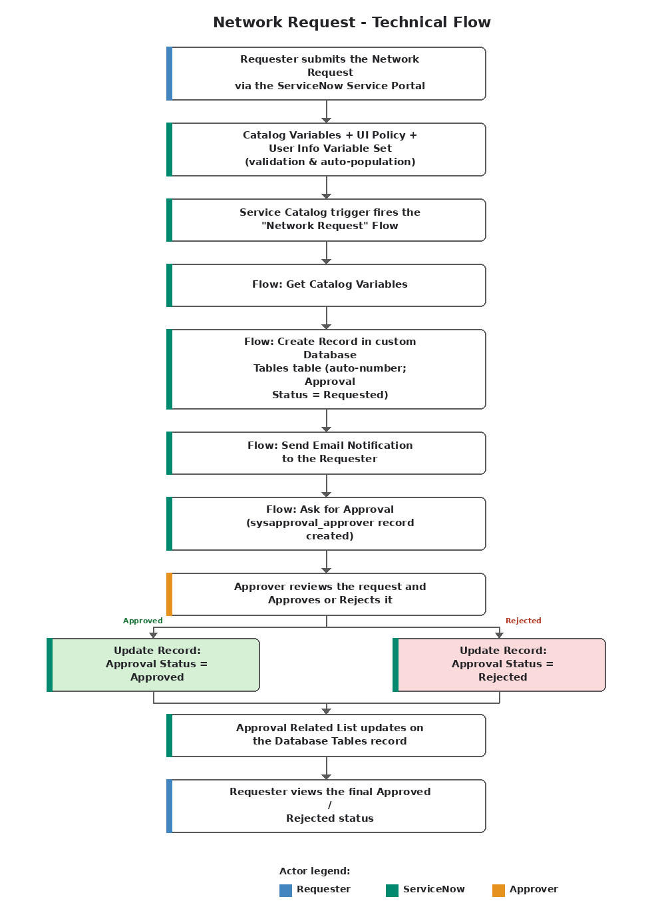
Table-1: Components & Technologies
S.No | Component | Description | Technology
1 | User Interface | How the requester interacts with the application | ServiceNow Service Portal - "Network Request" Catalog Item
2 | Application Logic-1 | Captures request details and validates/auto-populates them before submission | Catalog Variables, Catalog UI Policy, User Information Variable Set (auto-population)
3 | Application Logic-2 | Orchestrates backend record creation, notification and approval end to end | ServiceNow Flow Designer ("Network Request" flow, Service Catalog trigger)
4 | Application Logic-3 | Routes the created request for approval and evaluates the outcome | ServiceNow native Approval Engine (Ask for Approval action, sysapproval_approver)
5 | Database | Stores submitted network-request data as structured records | Custom "Database Tables" table created in the ServiceNow scoped application
6 | Cloud Database | Underlying data store for the ServiceNow instance | ServiceNow Platform multi-instance cloud database (native to the ServiceNow SaaS platform; no separate external database service is used)
7 | File Storage | File/attachment storage requirements | Not implemented — the current form does not require file attachments
8 | External API-1 | Purpose of an external API consumed by the application | Not implemented in this project (see Future Enhancements)
9 | External API-2 | Purpose of an external API consumed by the application | Not implemented in this project (see Future Enhancements)
10 | Machine Learning Model | Purpose of a machine-learning model used by the application | Not applicable / not implemented in this project
11 | Infrastructure (Server / Cloud) | Where the application is deployed | ServiceNow multi-tenant cloud instance (scoped application); deployment and hosting are fully managed by the ServiceNow platform — no separate server was provisioned by the team

Table-2: Application Characteristics
S.No | Characteristics | Description | Technology
1 | Open-Source Frameworks | The Service Portal's widget framework is bundled and managed by the ServiceNow platform itself; no additional third-party open-source framework was introduced by the project | ServiceNow Service Portal (built on AngularJS 1.x, provided natively by the platform)
2 | Security Implementations | Access to the custom table and catalog item relies on ServiceNow's platform-level security rather than a custom-built framework | Default ServiceNow ACLs (role-based access control) auto-generated for the table, plus platform-standard HTTPS/TLS in transit
3 | Scalable Architecture | The solution is a configuration on top of ServiceNow's native multi-instance SaaS architecture, which scales without any custom-built scaling logic | ServiceNow Now Platform (multi-instance cloud architecture, managed by ServiceNow)
4 | Availability | Uptime, failover and load balancing are provided by the ServiceNow cloud hosting itself; the project did not stand up its own servers | ServiceNow SLA-backed cloud hosting (platform-managed high availability)
5 | Performance | Flow Designer executes asynchronously so the requester's submission is not blocked while backend processing, email and approval creation complete | ServiceNow Flow Designer asynchronous execution; standard Service Portal client-side caching
References
https://www.servicenow.com/docs/
https://developer.servicenow.com/dev.do
https://docs.servicenow.com/bundle/latest-release-notes/page/release-notes/family-planning/flow-designer.html
https://c4model.com/

